SIEM Implementation and Threat Detection
Using Splunk, Kali Linux, and Ubuntu

Submitted by
Paulson K Babu

Cybersecurity Enthusiast | SOC Analyst Aspirant

March 2026

Project Type: Cybersecurity Lab Project

Abstract
This project presents the design and implementation of a Security Information and Event Management (SIEM) laboratory environment using Splunk Enterprise as the core platform, integrated with Kali Linux as the attacker machine and Ubuntu as the target system. The primary objective was to simulate real-world cyberattacks and develop detection mechanisms using Splunk's powerful querying and visualization capabilities.
Authentication logs from the Ubuntu machine were collected and forwarded to Splunk, where custom SPL (Search Processing Language) queries were developed to detect suspicious activities such as SSH brute-force attacks and privilege escalation attempts. SOC (Security Operations Center) dashboards were designed to provide a real-time visual overview of attacker behavior, and automated real-time alerts were configured to trigger on abnormal login patterns.
The results demonstrate that Splunk is an effective and scalable platform for threat detection and log analysis. The project reinforces core concepts in log monitoring, incident detection, and security analytics — skills that are directly applicable to entry-level roles in cybersecurity such as SOC Analyst and Security Analyst.

1. Introduction

1.1 About Cybersecurity Monitoring
In today's digital landscape, cyber threats are growing in sophistication and frequency. Organizations face a wide range of attacks — from brute-force login attempts to advanced persistent threats (APTs). Cybersecurity monitoring is the continuous process of collecting, analyzing, and responding to security events across an organization's IT infrastructure.
A core component of any modern Security Operations Center (SOC) is a SIEM platform, which aggregates logs, correlates events, and provides analysts with the visibility needed to detect and respond to threats in near real-time. Without proper monitoring, attacks often go undetected for extended periods, leading to significant data breaches and system compromise.

1.2 Introduction to Splunk
Splunk is a leading SIEM and data analytics platform used extensively by security professionals worldwide. It enables organizations to collect machine-generated data — logs, events, and metrics — from virtually any source, index it, and make it searchable in real-time. Splunk provides SPL (Search Processing Language), a powerful query language that allows analysts to search, filter, correlate, and visualize data efficiently.
Key capabilities include real-time log ingestion and indexing, advanced search and correlation using SPL, interactive dashboards and visualizations, configurable real-time alerts, and integration with threat intelligence feeds. Splunk is widely used in enterprise SOC environments, making hands-on experience with the platform highly valuable for cybersecurity professionals.

2. Objectives of the Project
- Design and configure a SIEM lab environment using Splunk Enterprise, Kali Linux, and Ubuntu virtual machines.
- Collect and ingest Linux authentication logs (/var/log/auth.log) into Splunk for real-time analysis.
- Simulate common cyberattacks including SSH brute-force attacks (using Hydra) and privilege escalation in a controlled environment.
- Develop SPL queries to detect suspicious login activity such as failed authentication attempts, invalid usernames, and repeated access from single IP addresses.
- Configure real-time automated alerts in Splunk that trigger when predefined brute-force thresholds are exceeded.
- Design and build SOC dashboards that visualize attacker behavior, top attacking IPs, failed login timelines, and sudo usage.
- Analyze and document results and findings from the simulated attack scenarios.

3. Tools and Technologies Used

3.1 Splunk Enterprise
Splunk Enterprise is the core SIEM platform used in this project, deployed on the Ubuntu machine to collect, index, and analyze authentication logs.

Version | Splunk Enterprise 9.x
Role | SIEM platform, log indexer, dashboard and alert engine
Web UI Port | 8000
Forwarder Port | 9997
Query Language | SPL (Search Processing Language)

3.2 Kali Linux (Attacker Machine)
Kali Linux is a Debian-based penetration testing distribution. It served as the attacker machine in this project. The tool Hydra was used to launch SSH brute-force attacks against the Ubuntu target.

3.3 Ubuntu Linux (Target Machine)
Ubuntu Linux acted as the victim/target system running the OpenSSH server. All authentication events were captured in /var/log/auth.log and forwarded to Splunk for analysis.

3.4 Supporting Tools

Hydra | Brute-force tool on Kali Linux used for SSH password attacks
Splunk Universal Forwarder | Agent on Ubuntu that ships logs to the Splunk indexer
VirtualBox | Virtualization platform hosting all VMs in the lab
OpenSSH Server | SSH service on Ubuntu — primary attack surface
rockyou.txt wordlist | Password dictionary used by Hydra for brute-force simulation

4. System Architecture / Workflow
The diagram below illustrates the end-to-end architecture of the SIEM lab environment, showing how the attacker, target, log forwarding, and Splunk analysis components interact.

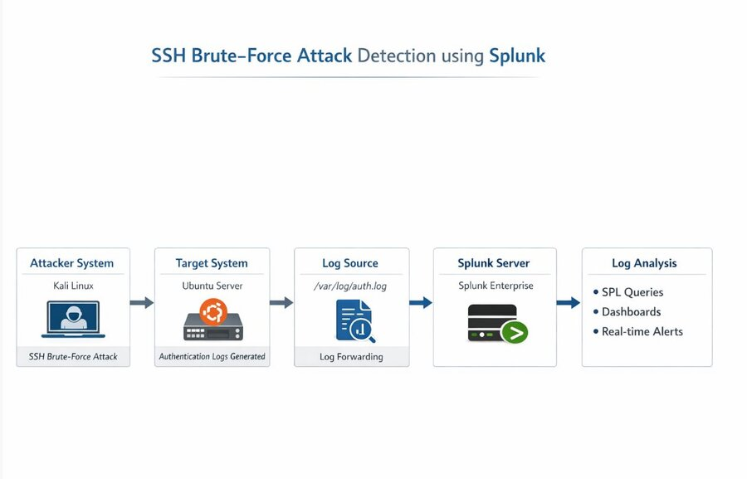
Figure 1: SSH Brute-Force Attack Detection Architecture using Splunk

The architecture consists of three main components:
- Attacker Machine (Kali Linux): Initiates simulated SSH brute-force attacks using Hydra against the Ubuntu target.
- Target Machine (Ubuntu): Runs OpenSSH server. All authentication events are recorded in /var/log/auth.log and forwarded to Splunk via the Universal Forwarder.
- SIEM Platform (Splunk Enterprise): Receives and indexes the forwarded logs, processes SPL detection queries, fires real-time alerts, and renders SOC dashboards.

Workflow Summary:
- Attacker (Kali Linux) sends SSH brute-force attempts to the Ubuntu target (192.168.50.4).
- Ubuntu records all authentication events in /var/log/auth.log.
- Splunk Universal Forwarder ships these logs to the Splunk indexer in real-time.
- Splunk indexes the logs under sourcetype=linux_secure.
- Detection queries identify brute-force patterns and privilege escalation events.
- Real-time alerts fire when thresholds are crossed; dashboards provide visual summaries.

5. Implementation Steps

5.1 Setting Up the Lab Environment
Three virtual machines were configured in VirtualBox on a host-only network (192.168.50.x):
- Ubuntu VM (192.168.50.4) — target machine with OpenSSH server installed and enabled.
- Kali Linux VM (192.168.50.1) — attacker machine with Hydra installed.
- Splunk Enterprise installed on the Ubuntu VM, accessible via the web interface at http://127.0.0.1:8000.

The screenshot below shows the SSH service running on Ubuntu, confirming the target was ready to receive connections:
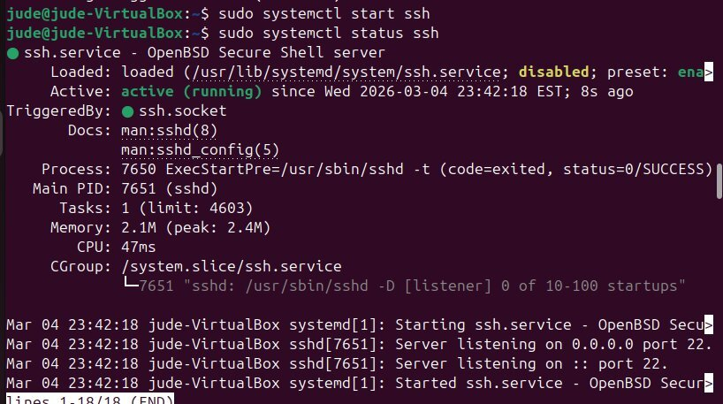
Figure 2: SSH service active and running on the Ubuntu target machine

A successful SSH connection was verified from Kali Linux to Ubuntu before launching the attack simulation:
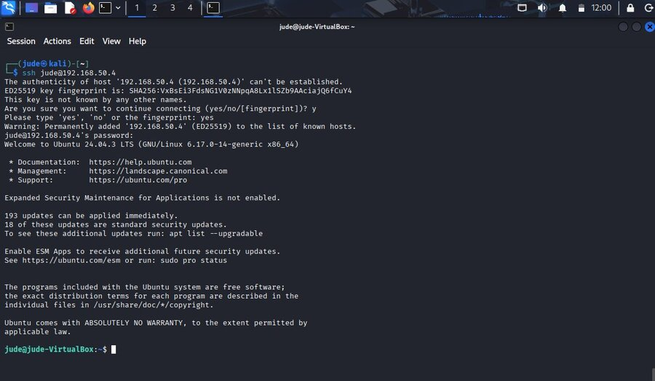
Figure 3: Successful SSH login from Kali Linux (192.168.50.1) to Ubuntu (192.168.50.4)

5.2 Data Ingestion — Configuring Log Forwarding
The /var/log/auth.log file on Ubuntu was configured as a monitored data input in Splunk. The Add Data wizard was used to set up continuous file monitoring with the following configuration:

Input Type | File Monitor
Source Path | /var/log/auth.log
Continuously Monitor | Yes
Source Type | linux_secure
Host | jude-VirtualBox
Index | main

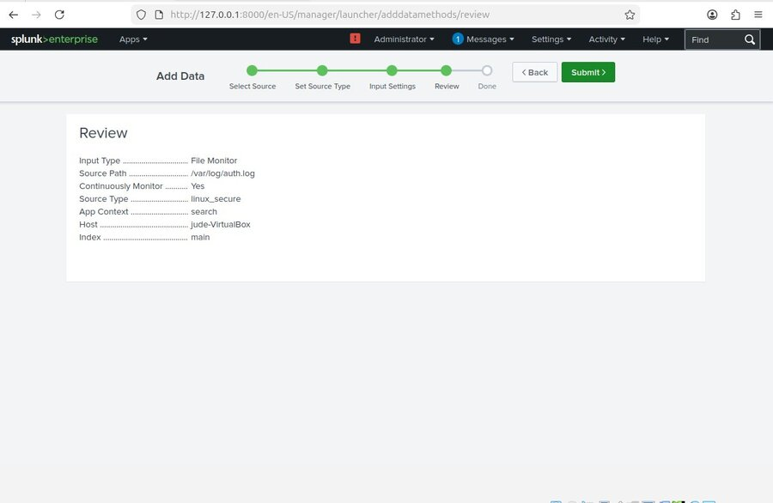
Figure 4: Splunk Add Data — Review screen confirming /var/log/auth.log ingestion configuration

5.3 Verifying Log Ingestion
After configuration, a search query was run in Splunk to confirm that authentication logs were being ingested correctly. A total of 441 events were indexed from /var/log/auth.log, confirming successful data ingestion.
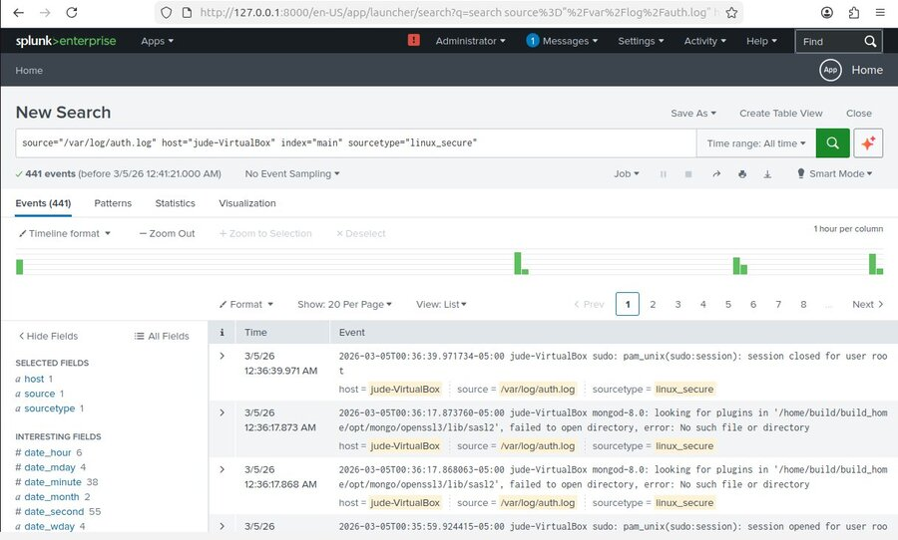
Figure 5: Splunk search showing 441 events indexed from /var/log/auth.log (sourcetype=linux_secure)

5.4 Simulating Attacks
Two types of attacks were simulated from the Kali Linux machine:
SSH Manual Failed Login Attempts:
Multiple failed SSH login attempts were made manually from Kali to Ubuntu using wrong passwords. These generated 'Failed password' and 'Permission denied' events in auth.log.
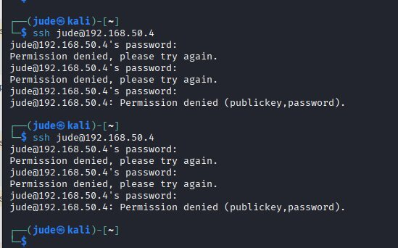
Figure 6: Manual SSH failed login attempts from Kali Linux — 'Permission denied' responses from Ubuntu

SSH Brute-Force Attack using Hydra:
Hydra was used with the rockyou.txt wordlist to launch an automated SSH brute-force attack against the Ubuntu target. This generated a large volume of failed authentication events in Splunk — 525 events detected in the last 24 hours during peak attack windows.
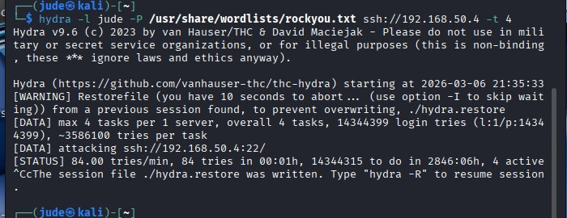
Figure 7: Hydra brute-force attack launched from Kali Linux against SSH on 192.168.50.4

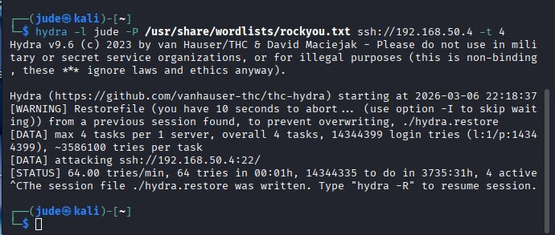
Figure 8: Second Hydra brute-force session — 64 login attempts per minute at peak

5.5 SOC Dashboard Creation
A SOC Dashboard titled 'Soc Dashboard' was created in Splunk with multiple panels to visualize attacker behavior. The Edit Dashboard interface was used to add panels from the panel library:
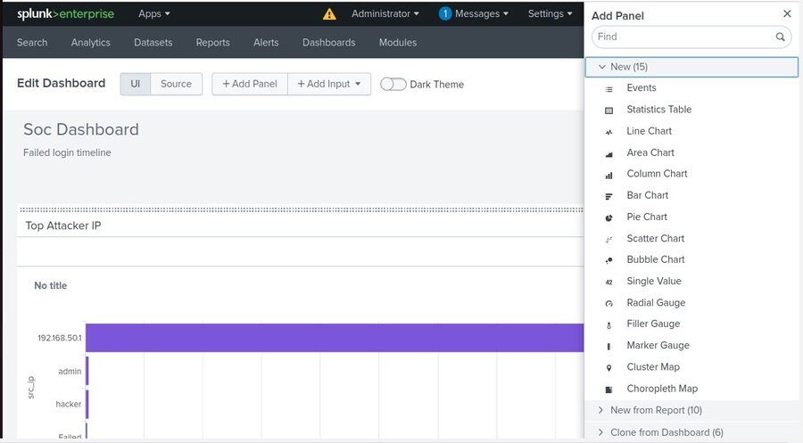
Figure 9: Splunk Edit Dashboard — SOC Dashboard with Top Attacker IP panel visible

New panels were added using the Add Panel dialog, with custom SPL queries entered for each visualization:
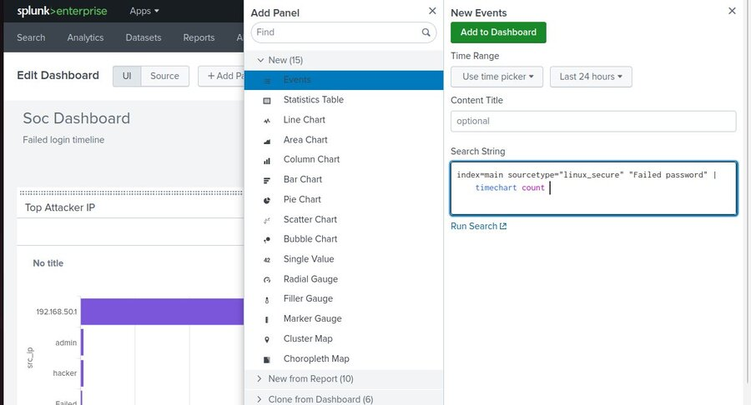
Figure 10: Add Panel dialog — configuring the Failed Login Timeline panel with timechart SPL query

The timechart visualization was configured and saved to the existing SOC Dashboard:
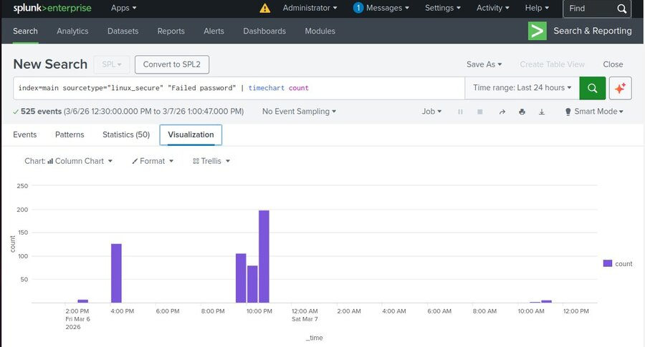
Figure 11: Timechart visualization of 525 failed password events over 24 hours

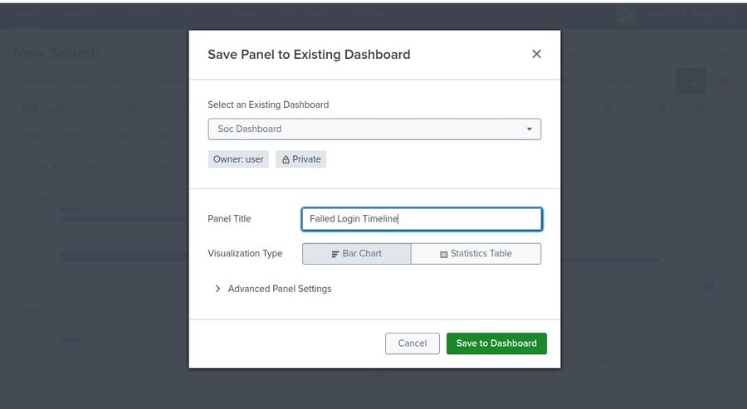
Figure 12: Saving the 'Failed Login Timeline' panel as a Bar Chart to the SOC Dashboard

5.6 Alert Configuration
Real-time alerts were configured in Splunk to automatically detect brute-force attacks as they occur. The alert titled 'Bruteforce Detection' was configured with the following settings:

Alert Title | Bruteforce Detection
Description | 5 failed login attempts from same IP within 1 minute
Alert Type | Real-time
Trigger Condition | Number of Results > 0 in 1 minute
Trigger | Once (with throttle: suppress for 10 minutes)
Severity | High
Action | Add to Triggered Alerts

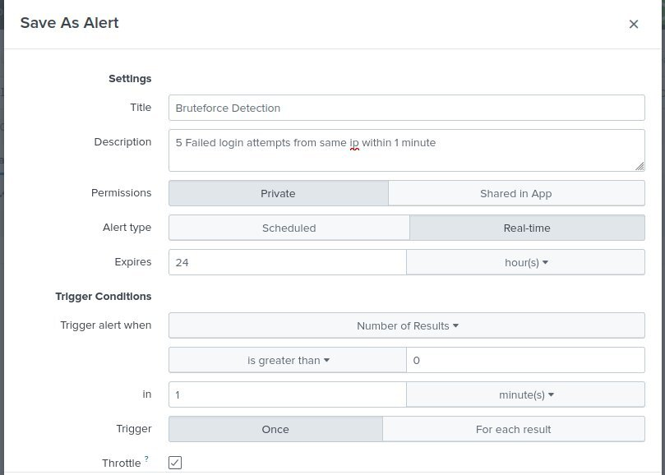
Figure 13: Save As Alert — Bruteforce Detection alert configuration settings

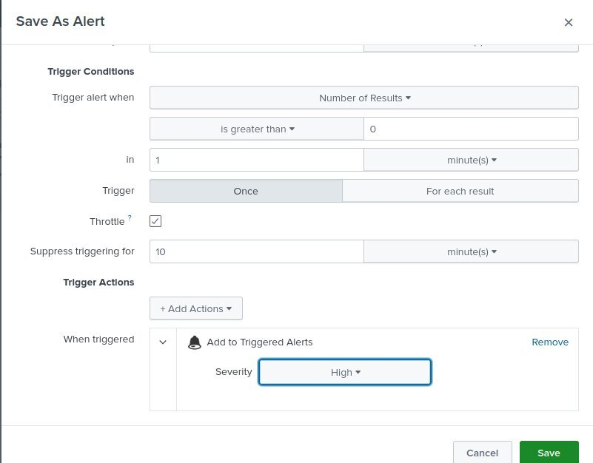
Figure 14: Alert trigger conditions and action — High severity, real-time, add to Triggered Alerts

6. Sample SPL Queries Used

6.1 Search All Failed SSH Login Attempts
search source=/var/log/auth.log "failed password"

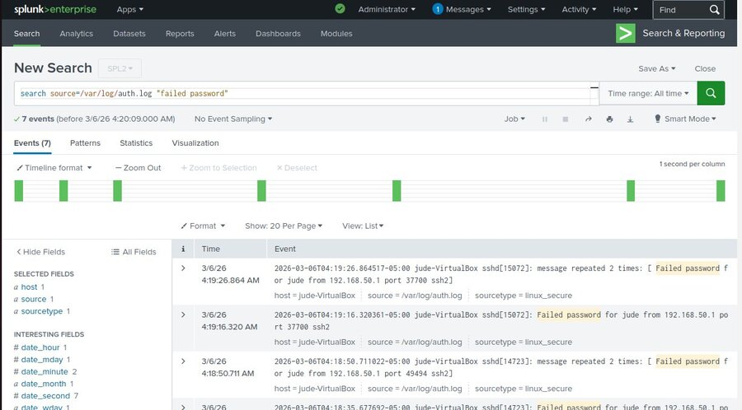
Figure 15: SPL query detecting 7 'Failed password' events from /var/log/auth.log

6.2 Brute-Force Detection (Threshold-Based)
index=main sourcetype="linux_secure" "failed password"
| bucket _time span=1m
| stats count by src_ip
| where count>=5

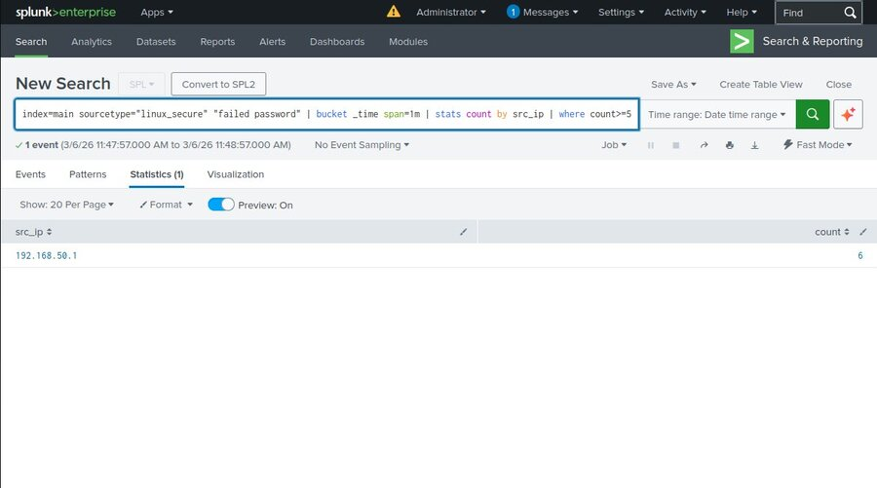
Figure 16: Brute-force threshold query — IP 192.168.50.1 generated 6 failed logins in 1 minute

6.3 Failed Login Timeline (Timechart)
index=main sourcetype="linux_secure" "Failed password"
| timechart count


Figure 17: Timechart of failed password events — 525 total events over the last 24 hours

6.4 Detect Invalid User Login Attempts
This query extracts invalid usernames and source IPs from auth.log using regex, filters out null values, and counts attempts grouped by username and IP. The visualization shows that 'hacker', 'admin', and 'fakeuser' were the top targeted invalid usernames, with 16 events detected.
index=main sourcetype="linux_secure" "invalid user"
| rex "(?i)invalid user (?<extracted_user>\w+) from (?<extracted_ip>\d+\.\d+\.\d+\.\d+)"
| where isnotnull(extracted_user) AND isnotnull(extracted_ip)
| stats count by extracted_user, extracted_ip
| sort - count

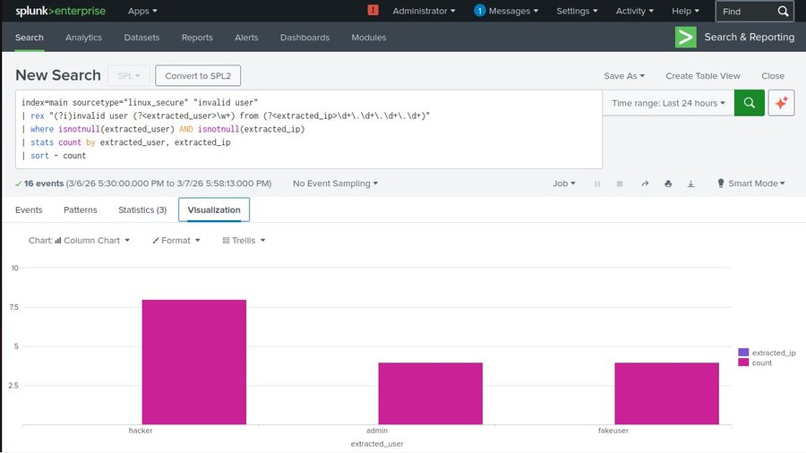
Figure 21: Invalid user login attempts — 'hacker', 'admin', and 'fakeuser' were the top targeted usernames (16 events)

6.5 Detect Privilege Escalation via sudo
This query identifies all sudo command executions by extracting the executing username using regex, then counts events grouped by username. The result shows user 'jude' executed 22 sudo commands, confirming privilege escalation activity was successfully captured.
index=main sourcetype="linux_secure" "sudo"
| rex "sudo:\s+(?<extracted_user>\w+)\s+:"
| where isnotnull(extracted_user)
| stats count by extracted_user
| sort - count

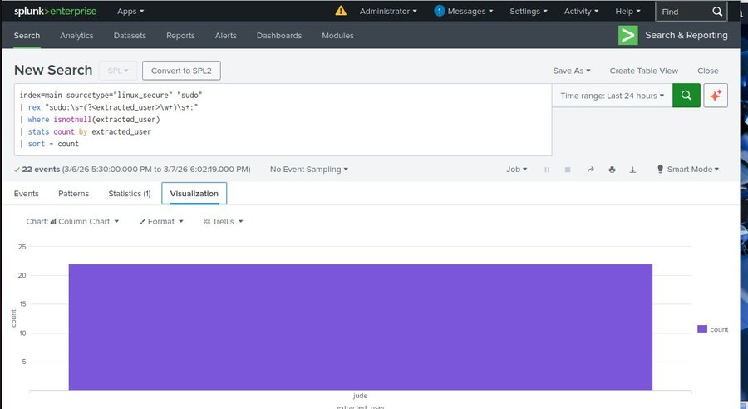
Figure 22: Privilege escalation detection — user 'jude' executed 22 sudo commands (22 events captured)

6.6 Top Attacking IP Addresses
This query identifies the top source IP addresses generating invalid user login attempts, using regex to extract the attacker IP and filtering for valid results. The result confirms that 192.168.50.1 (Kali Linux attacker machine) was responsible for all 16 invalid user login attempts.
index=main sourcetype="linux_secure" "invalid user"
| rex "(?i)invalid user (?<extracted_user>\w+) from (?<extracted_ip>\d+\.\d+\.\d+\.\d+)"
| where isnotnull(extracted_ip)
| stats count by extracted_ip
| sort - count
| head 10

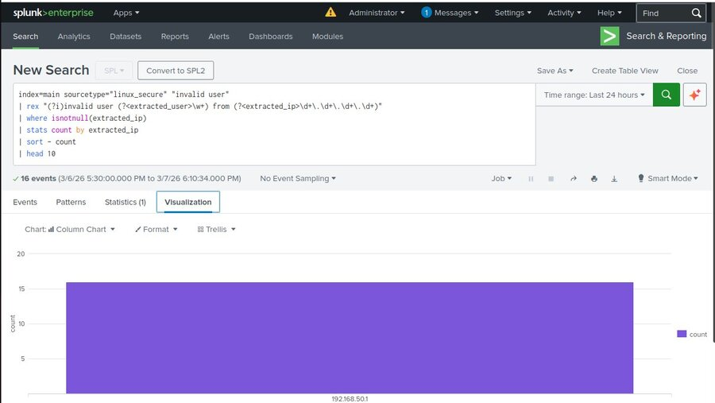
Figure 23: Top attacking IP — 192.168.50.1 (Kali Linux) responsible for all 16 invalid user login attempts

7. Results and Analysis

7.1 Alert Triggered Successfully
The real-time Bruteforce Detection alert fired correctly during the Hydra attack simulation. The Triggered Alerts panel in Splunk confirmed the alert was raised at 2026-03-06 11:48:57 EST with High severity, validating the detection logic.
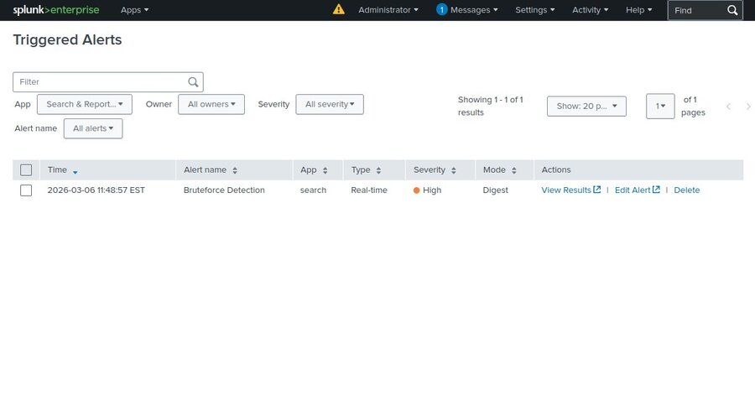
Figure 18: Triggered Alerts in Splunk — Bruteforce Detection alert fired at High severity

7.2 SOC Dashboard Results
The SOC Dashboard provided a comprehensive visual overview of all attacker activity. The dashboard showed two main findings:

Top Attacker IP and Invalid User Attempts:
The IP address 192.168.50.1 (Kali Linux attacker) was identified as generating nearly 400 failed login attempts. Invalid username attempts using 'admin' and 'hacker' were also clearly visible in the Invalid User Attempts panel.
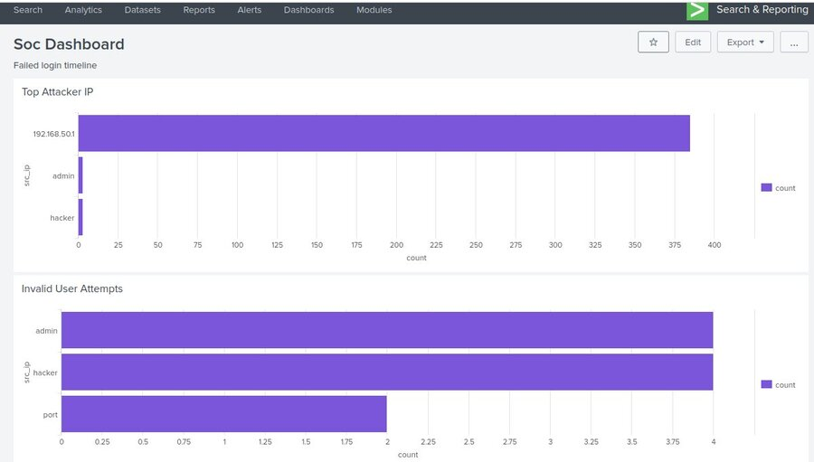
Figure 19: SOC Dashboard — Top Attacker IP (192.168.50.1, ~400 attempts) and Invalid User Attempts by username

Failed Login Timeline and Sudo Usage:
The Failed Login Timeline panel showed peak attack activity between 5:00 PM on March 6 and 1:00 AM on March 7, 2026, with over 190 failed login events in the highest time bucket. The Sudo Usage panel confirmed the username 'jude' executed sudo commands, demonstrating that privilege escalation activity was also captured.
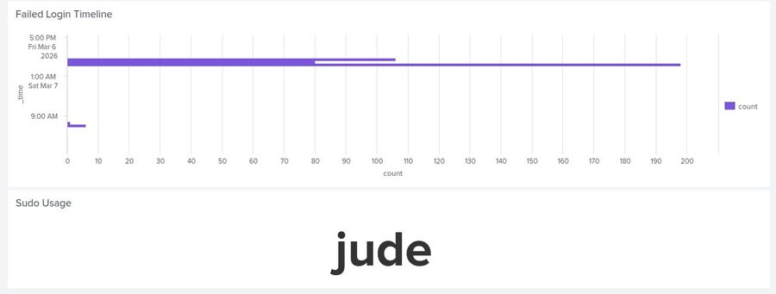
Figure 20: SOC Dashboard — Failed Login Timeline showing attack peaks, and Sudo Usage showing 'Paulson K Babu' (jude)

7.3 Key Findings Summary

Total Events Indexed | 525+ failed password events in 24-hour window
Top Attacker IP | 192.168.50.1 (Kali Linux) — approximately 400 attempts
Invalid Usernames Targeted | admin, hacker — top two invalid usernames attacked
Alert Accuracy | Brute-force alert triggered correctly with no false positives during normal operation
Privilege Escalation | Sudo usage by user 'Paulson K Babu' (jude) — 22 sudo commands captured
Attack Peak Time | 5:00 PM March 6 – 1:00 AM March 7, 2026

8. Advantages of Using Splunk
- Real-Time Log Analysis: Splunk ingests and indexes log data in real-time, enabling immediate detection of security incidents as they occur.
- Powerful Query Language (SPL): SPL allows analysts to perform complex searches, correlations, and statistical analysis on large volumes of log data.
- Scalability: Splunk can scale from small lab environments to enterprise deployments handling terabytes of data per day.
- Customizable Dashboards: The dashboard builder enables SOC analysts to create role-specific views that provide actionable insights at a glance.
- Flexible Real-Time Alerting: Alert conditions are highly customizable with multiple action types, supporting automated incident response workflows.
- Wide Data Source Support: Splunk supports hundreds of data inputs including syslog, Windows Event Logs, cloud logs, and network devices.

9. Limitations
- Resource Intensive: Splunk Enterprise requires significant system resources (RAM, CPU, disk I/O), which was a constraint in this virtual lab environment.
- Licensing Costs: The free version of Splunk is limited to 500 MB of daily data ingestion. Enterprise deployments require costly licensing.
- Learning Curve: SPL has a steep learning curve for beginners, particularly for writing efficient correlation queries.
- Simulated Environment: The lab does not fully replicate the complexity of a production network where lateral movement, encrypted traffic, and evasion techniques add difficulty to detection.
- No Packet Capture: This project focused on log-based detection only. Full packet capture (PCAP) analysis was outside the scope of this implementation.
- False Positive Tuning: Real-world environments produce more varied log patterns, requiring ongoing query tuning to minimize false positives.

10. Future Enhancements
- Threat Intelligence Integration: Incorporating threat intelligence platforms such as MISP or VirusTotal lookups to enrich alerts with known malicious IP data automatically.
- SOAR Integration: Connecting Splunk with a SOAR platform to automate incident response actions such as blocking attacker IPs at the firewall.
- Windows Log Monitoring: Expanding the lab to include Windows machines and monitoring Windows Security Event Logs (Event IDs 4625, 4672, 4698).
- Network Traffic Analysis: Integrating Zeek (Bro) or Suricata IDS with Splunk to add network-layer detection alongside host-based log monitoring.
- Machine Learning Anomaly Detection: Leveraging Splunk's Machine Learning Toolkit (MLTK) to build behavioral baselines and detect anomalous deviations.
- Cloud Log Integration: Extending the SIEM to ingest cloud service logs from AWS CloudTrail or Azure Monitor.

11. Conclusion
This project successfully demonstrated the design, implementation, and operation of a SIEM lab environment using Splunk Enterprise, Kali Linux, and Ubuntu. By simulating real-world attack scenarios including SSH brute-force attacks (using Hydra with rockyou.txt) and privilege escalation, and developing targeted detection mechanisms, the project replicated the core workflow of a Security Operations Center analyst.
Splunk proved to be a powerful and versatile SIEM platform. The platform ingested over 525 authentication log events during attack simulations, the brute-force detection query correctly identified the attacker IP (192.168.50.1) generating 6+ failed attempts per minute, the real-time alert fired accurately with High severity, and the SOC Dashboard provided a clear visual summary of attacker behavior including top attacking IPs, peak attack timelines, invalid username attempts, and sudo usage.
The knowledge and hands-on skills developed through this project — including log analysis, SPL querying, alert engineering, and SOC dashboard design — are directly applicable to entry-level cybersecurity roles such as SOC Analyst (Tier 1/2), Security Analyst, and Threat Detection Engineer. The project also provides a strong foundation for pursuing certifications such as Splunk Core Certified User and CompTIA Security+.

12. References
- Splunk Inc. (2024). Splunk Enterprise Documentation. https://docs.splunk.com/Documentation/Splunk
- Splunk Inc. (2024). Search Processing Language (SPL) Reference. https://docs.splunk.com/Documentation/Splunk/latest/SearchReference/
- Offensive Security. (2024). Kali Linux Tools — Hydra. https://www.kali.org/tools/hydra/
- Ubuntu Documentation. (2024). OpenSSH Server. Canonical Ltd. https://ubuntu.com/server/docs/openssh-server
- MITRE ATT&CK. (2024). T1110 – Brute Force. https://attack.mitre.org/techniques/T1110/
- NIST SP 800-92. (2006). Guide to Computer Security Log Management. NIST.

